

**Advanced Software Engineering**

Course # CSEE 5551 0001

Semester: Spring 2017

LAB Assignment # 9

Submission Date: 3/22/2017

Student Name: Satya Sai Deepthi Katta

Student ID: 16231371

**Instructor:** Dr. Yugyung Lee

**Email:** LeeYu@umkc.edu

**Department of Computer Science & Electrical Engineering**

**University of Missouri, Kansas City**

**Welcome to Lab Assignment #9 Wiki Page!**

Submission on 3/22/17

**Abstract:**

The main aim of this application is to create a Private REST service that is Mashup of at least two public REST services. This private web service is used in Web Application.

**TASK 1: Create a Private REST service that is Mashup of at least two public REST services.**

**The Web Application created is the Mashup of two public REST services**

1. **Four Square API which is used in searching for Places of Interest in Kansas City.**
2. **OpenWeatherMap API which gives the current weather report in Kansas City**

**Initially, the server and the client are created in the Local Host 8081. When the websites run correctly on the local host, a dialogue ‘Client Server running of local host: http address’ is given in the debug window. The screenshots are provided below.**

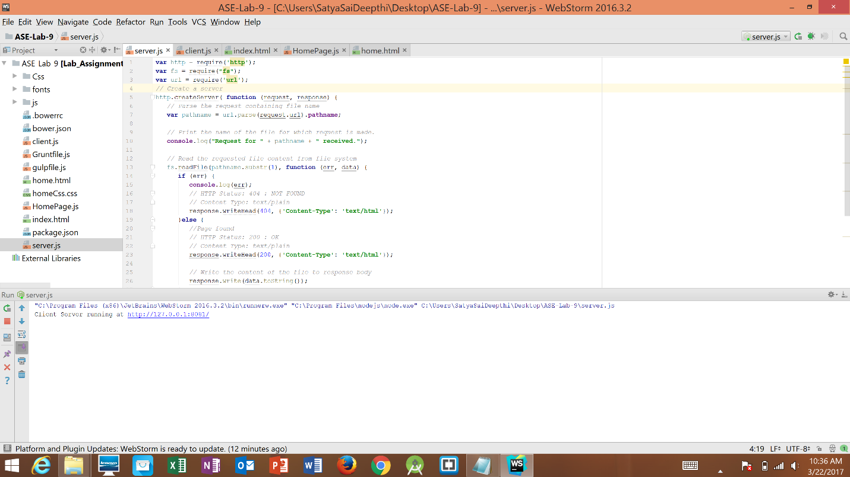

**Fig 1. Server running on Local host 8081**

**Now, on clicking the link it navigates to the web application created.**

**The index page of the web application contains the welcome note and button to the home page.**

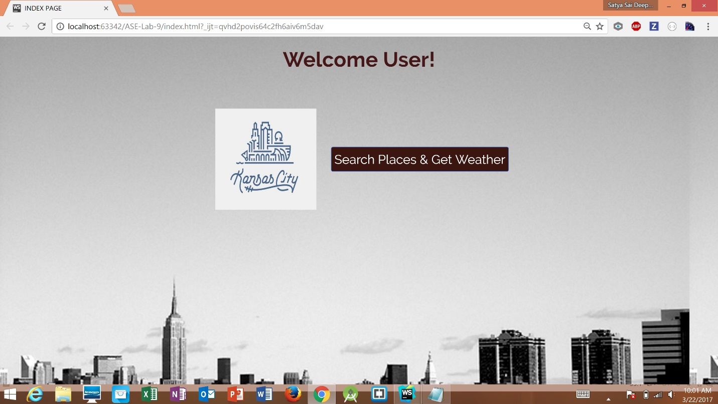

**Fig 2. Index Page for the Web Application.**

**A button is provided to search for the places and get weather of Kansas City. On clicking the button. The page navigates to the Home Page of the Web Application.**

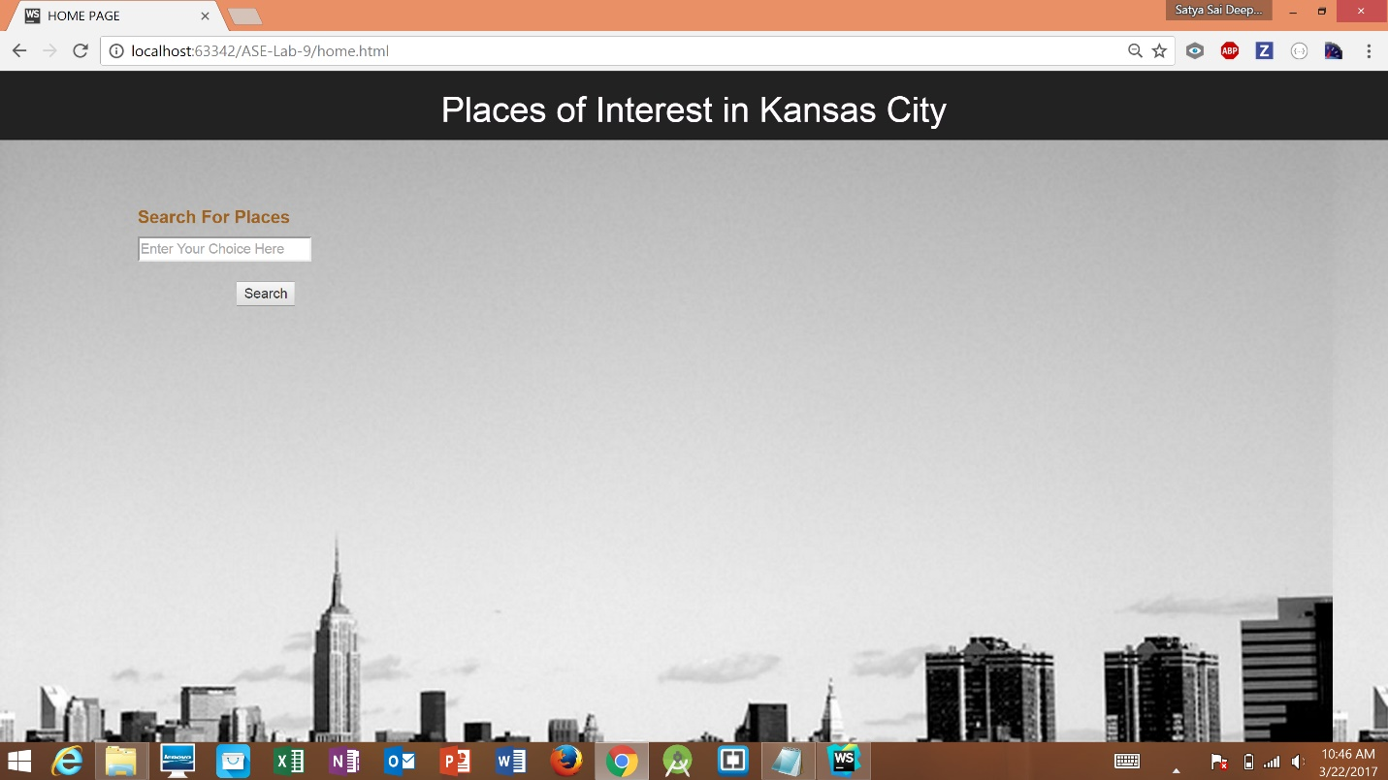

**Fig 3. Home Page of the Web Application created using REST Services.**

**TASK 2: Use this private web service in your web/mobile/hybrid application.**

**By Using the REST web services, the application is created in such a way that address and contact number for places search and current weather for the city are displayed on the Web Page. The details of the places like the address and contact are collected through the Four-Square API. Whereas detailed report of the current weather is taken form the OpenWeatherMap API and details are displayed in the tabular format.**

**Now, to search for places of your interest, a dialogue is provided with a search button below it. The screenshots are provided for various search results.**

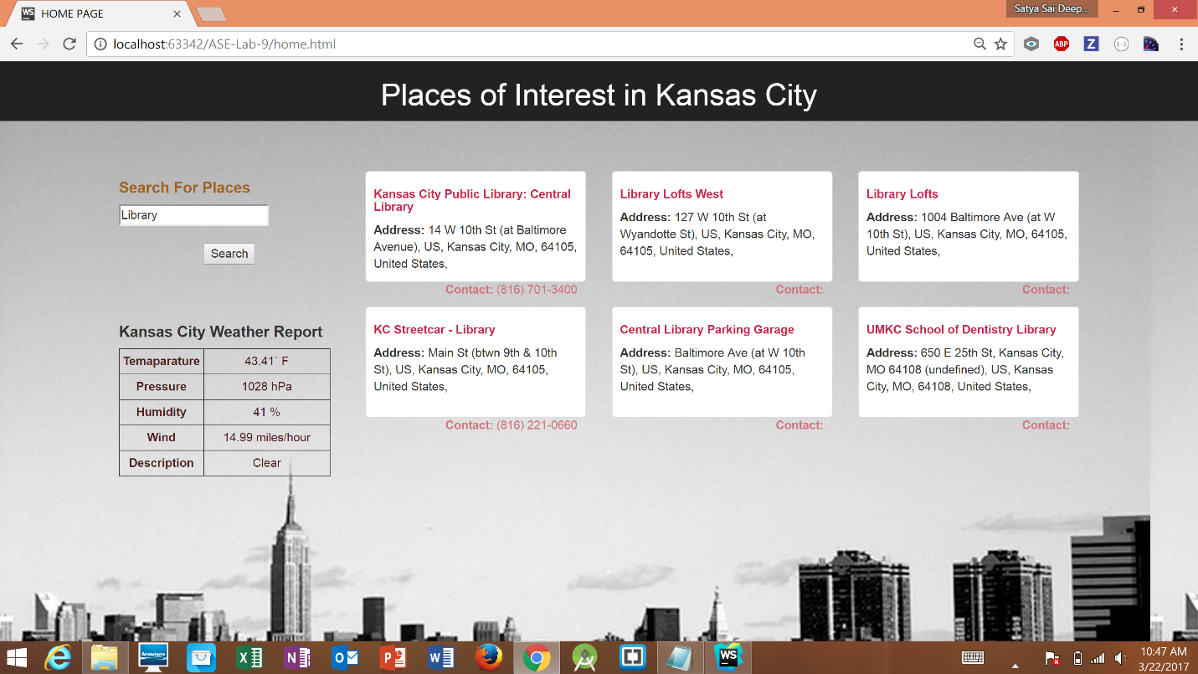

**Fig 4. Search Results for Library in Kansas City.**

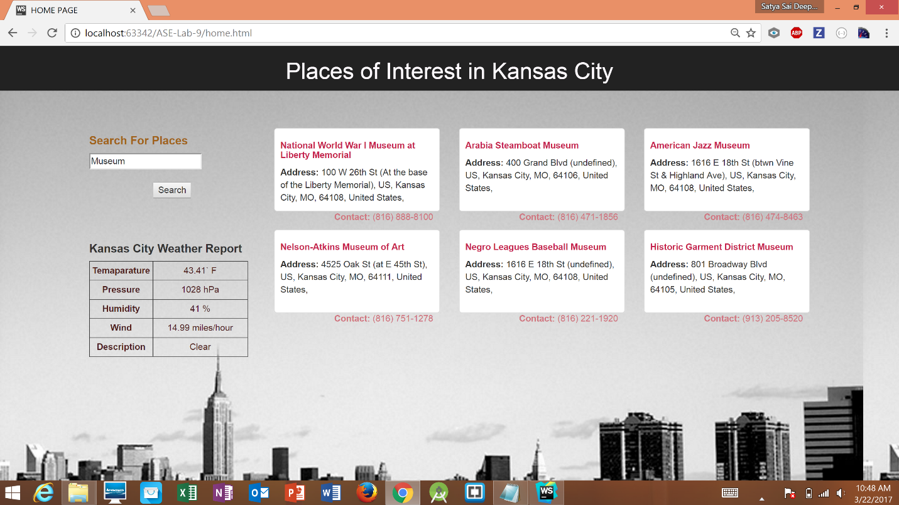

**Fig 5. Search Results for Museums in Kansas City.**

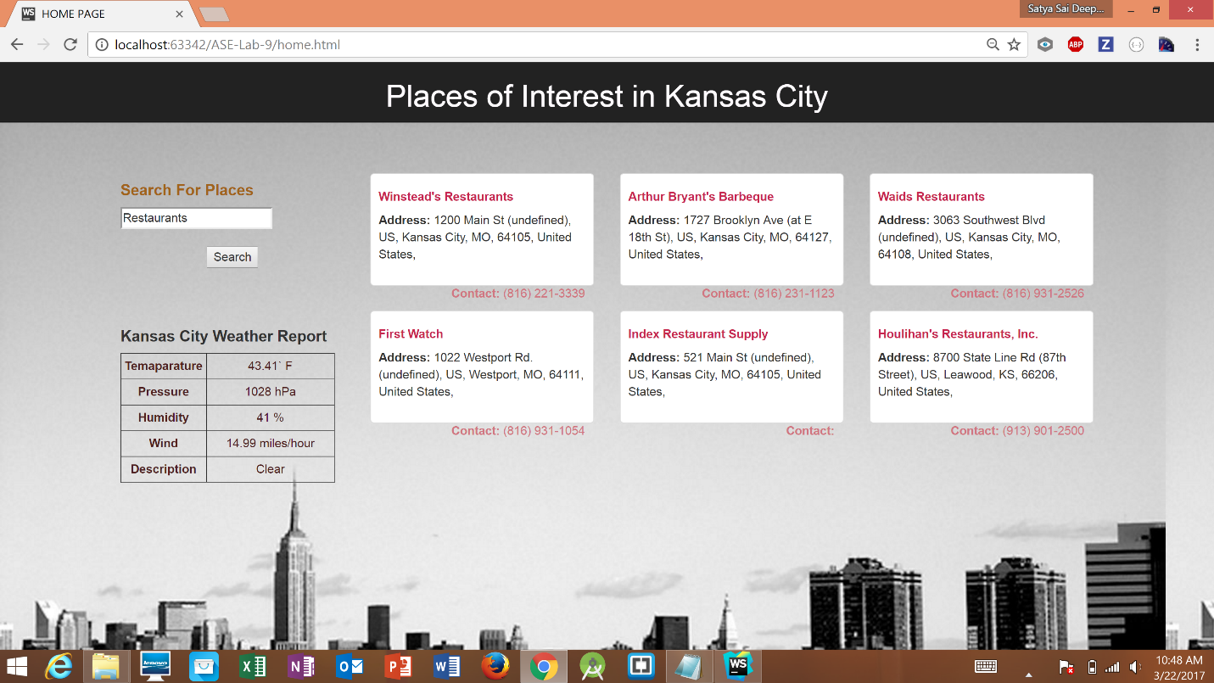

**Fig 6. Search Results for Restaurants in Kansas City.**

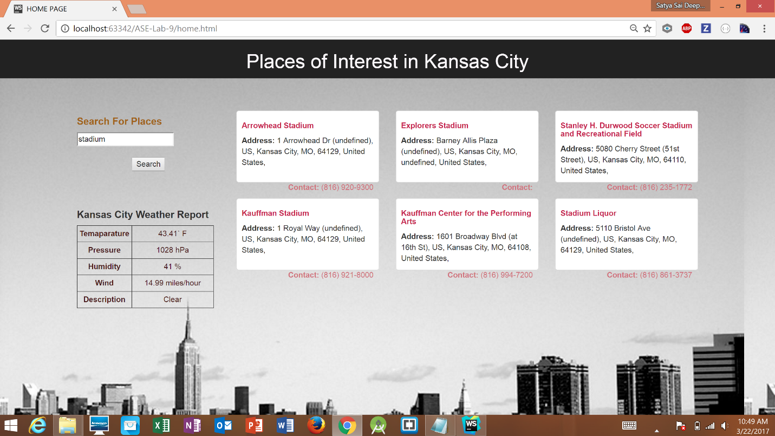

**Fig 7. Search Results for Stadiums in Kansas City.**

**The Web Pages are tested using YSlow Tool in Google Chrome Browser. The results are provided in the screenshots below.**

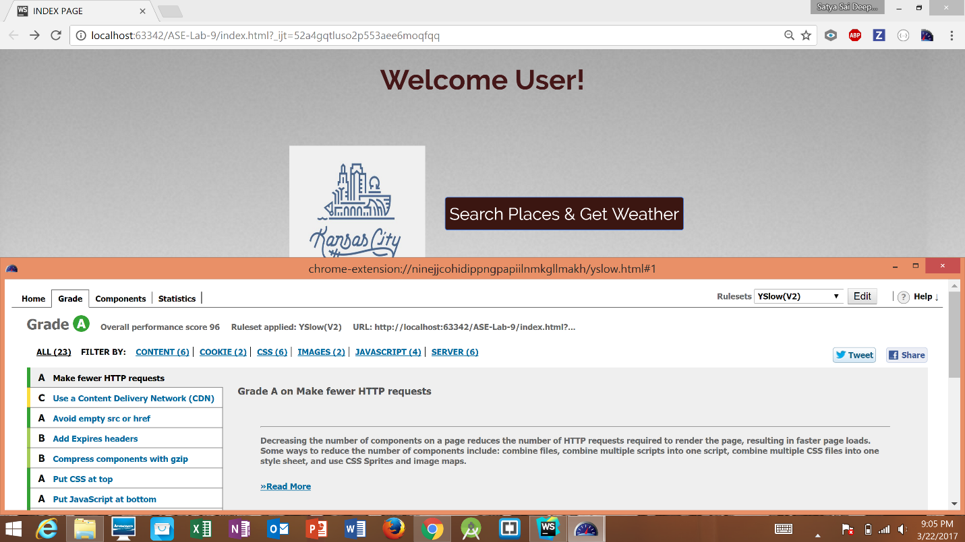

**Fig 8. YSlow Grade Results for Index Page.**

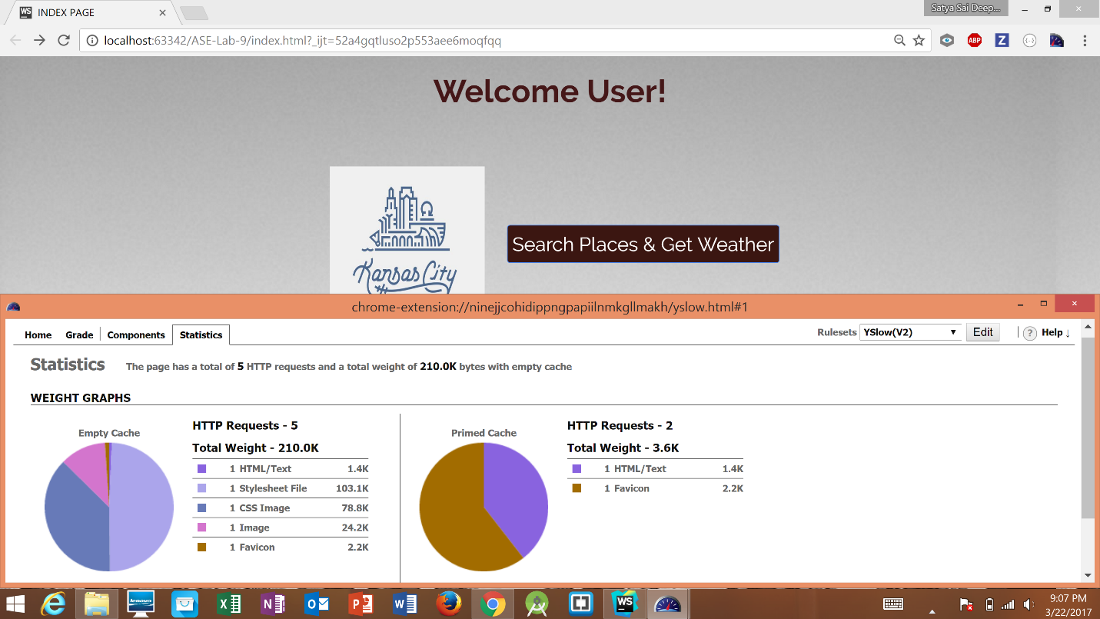

**Fig 9. YSlow Statistics for Index Page.**

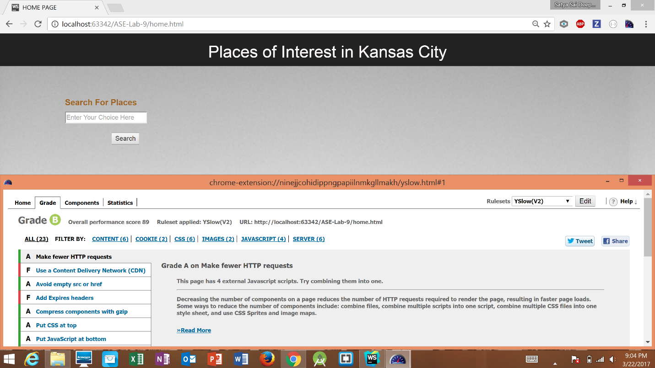

**Fig 10. YSlow Grade Results for Home Page.**

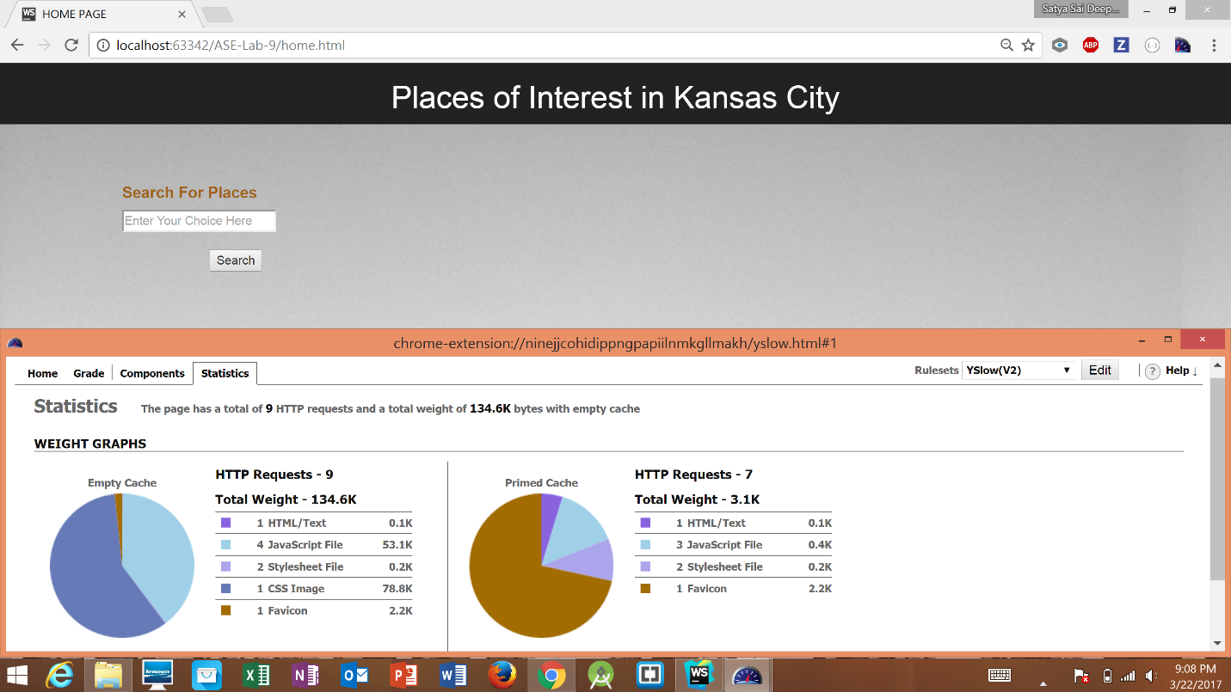

**Fig 11. YSlow Statistics for Home Page.**

**References:**

1. <http://stackoverflow.com/>
2. <http://www.restapitutorial.com/>
3. <https://www.tutorialspoint.com/restful/>
4. <https://developer.foursquare.com/>
5. <https://openweathermap.org/api>